Prepare for thesis:

1. General information
   1. Registering for CPIT 699: After the student successfully completes CPIT 695, the candidates (along with the title and supervisor) are approved by the department council and the registering of the thesis (including the candidate and the supervisor) is done through the deanship of postgraduate affairs.
   2. Female students can meet their male supervisors, if needed, near the cafeteria (on the ground floor, towards the left side from the main entrance) in King Fahd Medical Research Centre (KFMRC).
   3. If a room at KFMRC is needed, it could be booked at http://kfmrc.kau.edu.sa/Content.aspx?Site_ID=141&lng=EN&cid=229292
   4. Forms and rules are available at:

http://graduatestudies.kau.edu.sa/content.aspx?Site_ID=306&lng=AR&cid=237428&URL=www.kau.edu.sa

1. The thesis process is generally for a period of one semester (fourth semester), after the student completes all his courses.
2. **Seminar:** During this semester, student must present a seminar in the department. This seminar is mandatory. This seminar can be delivered anytime during his/her thesis period. The announcement of the seminar should be done through the vice dean of graduate studies.
3. ISI Journals listed by KAU:
   1. <http://prod.kau.edu.sa/dsr/akausr/akausr/ISI_Search.aspx>
4. Tasks by the supervisor:
   1. Once the student has completed his thesis work, supervisor should do the following:
      1. Change of title can be initiated on the higher education site by the supervisor. Make sure to do it before the defense committee request. This process takes around a week on the odus.
         1. **تعديل عنوان الرسالة العلمية ( 08 )**
         2. Make sure to put the correct English and Arabic titles. This needs an adhoc committee to be approved from the department. This committee will be arranged by the head of the department.
      2. Print a copy of his/her thesis and submit it to the chairman of the department through his supervisor. Along with the copy the form for the “Academic Council Affairs” has to be filled.
         1. Make sure to adhere to the “KAU-Checklist” provided by us.
         2. The following pages are present, in this order:
            1. Cover page: This page does not contain the supervisor name and it is in this format. For “Academic Council Affairs” checking, this page is not required but this page is print on the blue coloured hard bound page in the final thesis copy.
            2. Basamala page.
            3. Title page: This contains the supervisor name.
            4. Committee Approval page: This contains the committee names and for signatures.
         3. Only after the approval from the “Academic Council Affairs”, student is allowed to proceed further. Normally, it takes two or three weeks for this process to complete.
         4. Make sure the supervisor and the person who reviews the thesis are different, as this a requirement.
      3. Request the chairman of the department for the evaluation committee (Viva Committee). This process could be done only after the process for approval by “Academic Council Affairs”. The supervisor should provide the CV of the external examiner. Sometimes, the CV of the supervisors and internal examiner are also required. Then, the chairman of the department is requested to arrange the approval of the evaluation committee for the student. This process could be performed using a committee or through the department council. After the approval of the evaluation committee, the chairman of the department will update some information related to these in odusplus.
         1. Evaluation committee is comprised of supervisor, one external examiner and one internal examiner. Internal examiner is a person from our college (FCIT). External examiner is either from another college of our university (College of Engineering, …) or from another university (Taibah univ, ummul qura univ, etc).
         2. The defense committee should be in odd numbers. If there is a main supervisor and co-supervisor, then only one of them should be in the committee along with the internal and external examiners.
         3. One of the members of the evaluation committee should be an associate professor or above.
         4. One copy of the thesis is given to each of the evaluation committee members.
         5. This process takes a week to get the committee approved on the higher education site.
5. After the evaluation committee process the thesis, a presentation (defense) by the supervisor is announced through odus (option 18 in higher education site). This process is done by the Vice Dean of Graduate Studies through the department Chairman.
   1. **الاعلان عن موعد مناقشة رسالة علمية ( 18 )**
   2. For defense, the defense evaluation form and the observer form are required to be filled. These filled forms are necessary for the payment and graduation requests.
   3. Also, make the committee page of the thesis available for signature from the supervisor(s), internal and external examiners.
   4. If the external examiner is from outside Jeddah and travel ticket is required, then the supervisor has to be initiate the ticket request using [نموذج طلب استضافة مناقش من خارج محافظة جدة](http://www.kau.edu.sa/GetFile.aspx?id=248363&fn=نموذج%20طلب%20استضافة%20مناقش%20من%20خارج%20محافظة%20جد8-8-1436ة.doc) available at the Deanship of Graduate Studies website. This request has to be signed by the chairman and the vice dean for graduate studies. This has to be forwarded to the ادارة التخطيط والميزانية والمتابعة (Second floor in administration building, above the Passport office) through the communication section at FCIT. From ادارة التخطيط والميزانية والمتابعة, it will forwarded to ادارة العلاقات العامة (First floor in administration building, below President office) to issue ticket order. Then, you could purchase the ticket from ticket office. The ticketing process needs the full name of the external examiner in English, Date of Birth, Iqama number and Iqama expiry date. This process if followed might take a day or two.
6. Supervisor initiates the payment process for the defense committee on the odus.
   1. **طلب صرف مكافأة اعضاء لجنة مناقشة ( 27 )**
   2. **رقم حساب البنك, الجوال, الهوية of the external examiner is needed**
   3. For this, the supervisor passes the copy of the defense evaluation (evaluation and observer form) to the chairman in the system.
7. The next process is for the student to initiate the form to grant degree to the chairman through his/her supervisor.
   1. **طلب منح الدرجة العلمية (برسالة)**
   2. The initiation of payment process for the defense committee by the supervisor is a requirement to start this process.
   3. Supervisor forwards the graduation request to the chairman of the department.
   4. Also, the student should fill the form titled إخلاء طرف من الجامعة available from the deanship of graduate studies. This form requires the signature of the supervisor, followed by many others.
8. Many copies of the hardbound thesis is required to be submitted. The cover page should be in blue colour for Master degree.
   1. For Central Library: Two hardbound and 20 CDs are required.
   2. For Department: One hardbound copy with CD.
   3. For Faculty: One hardbound copy with CD.
   4. One (with CD) for Supervisor; One (with CD) for Co-Supervisor, if applicable
   5. **Copies NOT NEEDED**: three copies for deanship of graduate studies; One for internal examiner; One for External examiner.
   6. Hardbound cover page format and the CD label as given below:

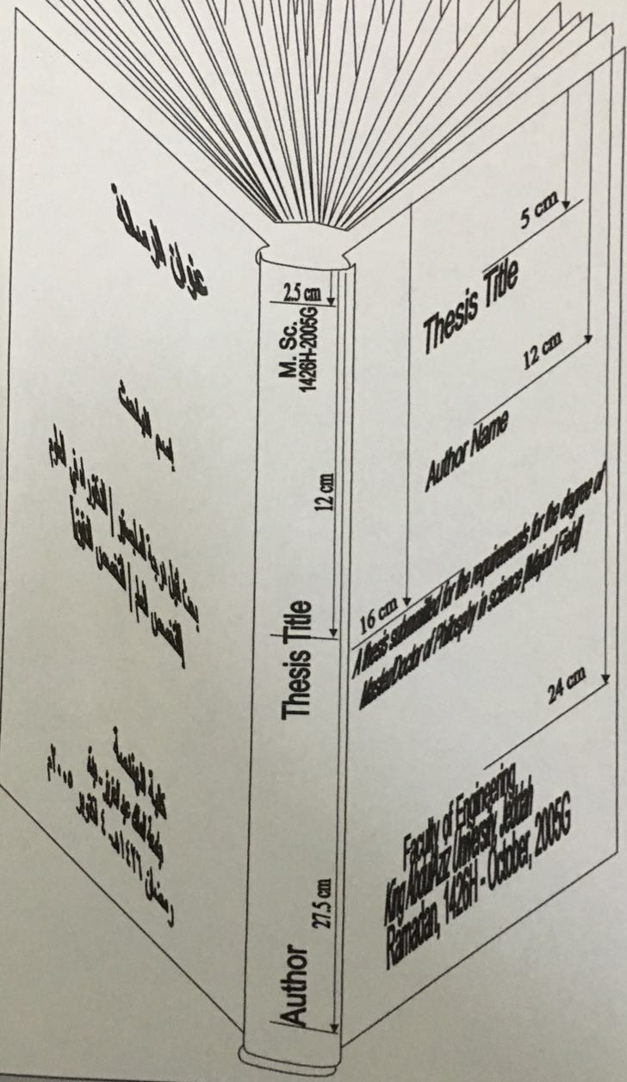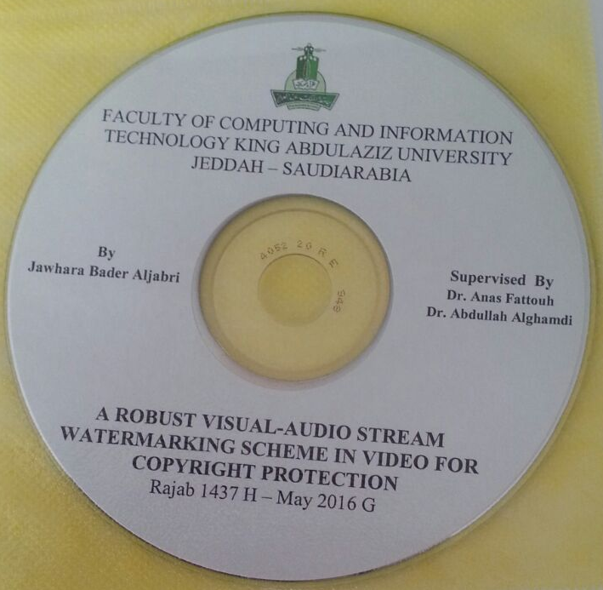

**Certain points:**

1. To publish a whole thesis as a book, the student should acquire approval from deanship of graduate studies.